GROUP CHAT

The goal of the exercise is to make an application for group chat. This allow users to chat with the others inside a group. The application also support storing history chat at server.
The application must be a Server-Client application. Client must be written in Java.
On the server side we expect the application to be deployed in a Container (any: OpenEJB, Glassfish…). The client should always communicate to one dedicated service interface (MessageService…). Services should be EJB beans.
How should the GUI look?
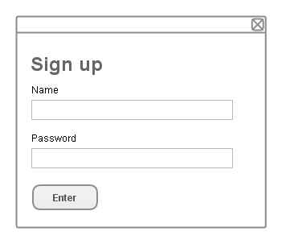
When start-up, signup screen should show first. There user enter username & password. If name & password matched in database, get user to next screen. If not, a new dialog should be shown to confirm password. If two password matched and name not exists, register user to database. Show error if name exists.
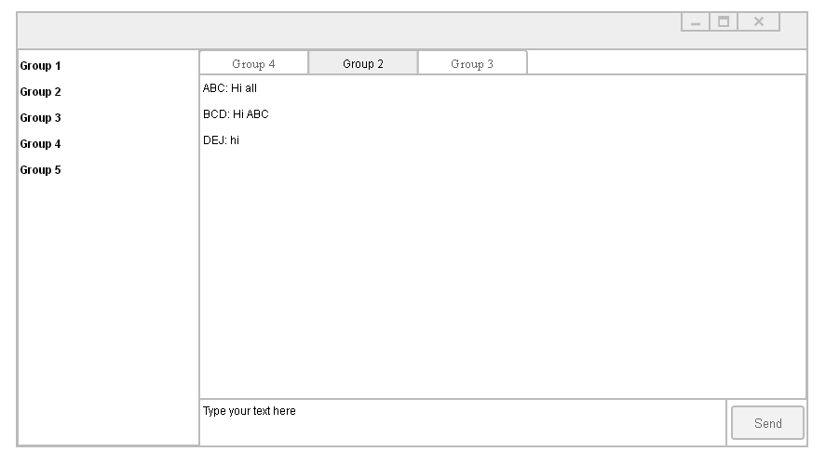
On the left is group selection. Group should be created before, no one can create new group. User select group and begin to chat. User can join multiple group.

Technology requirements

EJB
SERVER

EJB
CLIENT
Technologies need to be used:
Any framework for a simple GUI. Client should be able to receive server events.
Spring also support calling remote EJB bean
Technologies need to be used:
Spring + Hibernate (for database stuffs)
EJB (Remote Stateless, Message Driven)
Spring also support injecting into EJB

Advanced Feature: Support Clustering

